

Email Phone Name Address __________________

**2025 EBJ FALL PLANT SALE**

As EBJ says farewell to the heat of summer, we are again offering winter beauty! All plants will be in translucent “sleeves” for gift giving. We are hopeful for peace this year, and therefore we have added the Spathiphyllum/Peace Lily!!

The Edith B. Jackson Child Care Program thanks you for your past and continued support!

# Orders by USPS, email ([gracebright2015@gmail.com](mailto:gracebright2015@gmail.com)) or phone (203.887.1328 cell) accepted through November 4. NO LATE ORDERS!!

# CYCLAMEN 6” Pots

***Buy More and Save:***

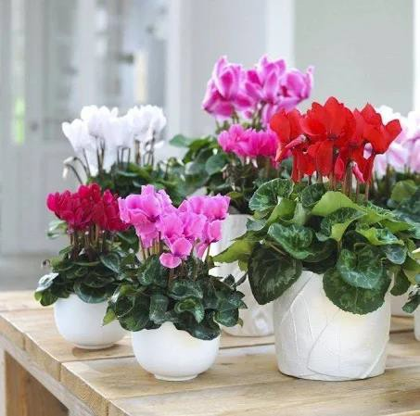

**1-4 Plants $15.50 each**

**5 + Plants $15.00 each**

**Cyclamen Color Choices are:**

**RED # ___ WHITE # _ LT PINK # DK PINK #____**

**Total CYCLAMEN POTS # Total $_________**

**Cyclamen**

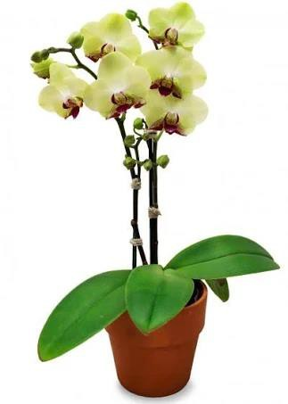 **PHALAENOPSIS ORCHIDS**  **5” Pots**

***(No Color Choice – Color range: orange, pink, yellow, purple, white)***

**Total Orchid pots # @ $26.50 = Total $**

# Peace Lily - Spathiphylum Plant SPATH / PEACE LILY #Pots $15.50 each = Total $____________

# 

# Total amount for selected plants = $________Check#_________Payable to EBJ Child Care Program

# OVER_________________________________________

# Unlike spring plants, these tender plants cannot be left outside …someone must be home to receive the plants at the time of delivery! PLEASE mark your choice:

# __Pick up at EBJ Thursday Nov. 20 ___ or Friday Nov. 21 ____ 5pm-5:15 pm (*Current Families Only*)

# __Pick up Saturday Nov. 22 @ 180 Livingston St. New Haven …11AM – 1 PM

# __EBJ will deliver Wednesday Nov. 19 ….10 am – noon

# __EBJ will deliver Wednesday Nov. 19 ….12:30 pm-2:30 pm

# __EBJ will deliver Thursday Nov. 20….2:30 pm-5 pm

# __EBJ will deliver Friday Nov. 21 …8 am-10 am

# __EBJ will deliver Friday Nov. 21…1 pm-2:30 pm

# __EBJ will deliver Saturday Nov. 22…8 am-10 am

# Questions or need other options for pickup/delivery, please call Grace Bright 203.887.1328

# EBJ Child Care Program is grateful for your past and continued support of quality childcare!!!

# 